**Deploy an Azure Kubernetes Service (AKS) cluster using Azure CLI**

**Open Azure Cloud Shell**

Please make sure to install Azure cli version 2.0.27 or later.

**Create a resource group**

Create a resource group with the az group create command. An Azure RG is a logical group in which Azure resources are deployed and managed. When creating a resource group we will be asked to specify a location, where your resources will live in Azure.

**Azure cli login:**



**Create resource group named AKSCluster in the eastus location.**

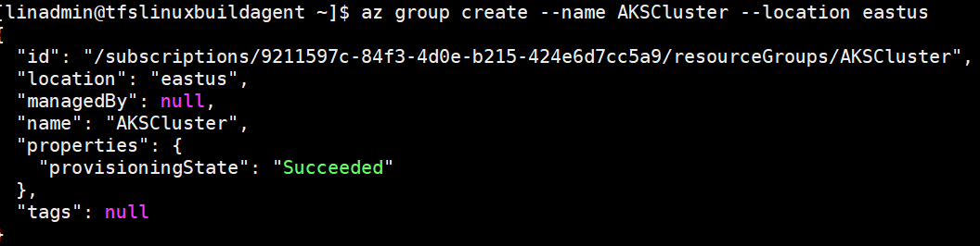

Create AKS cluster: Use the az aks create command to create an AKS cluster.

Create cluster named myAKSCluster .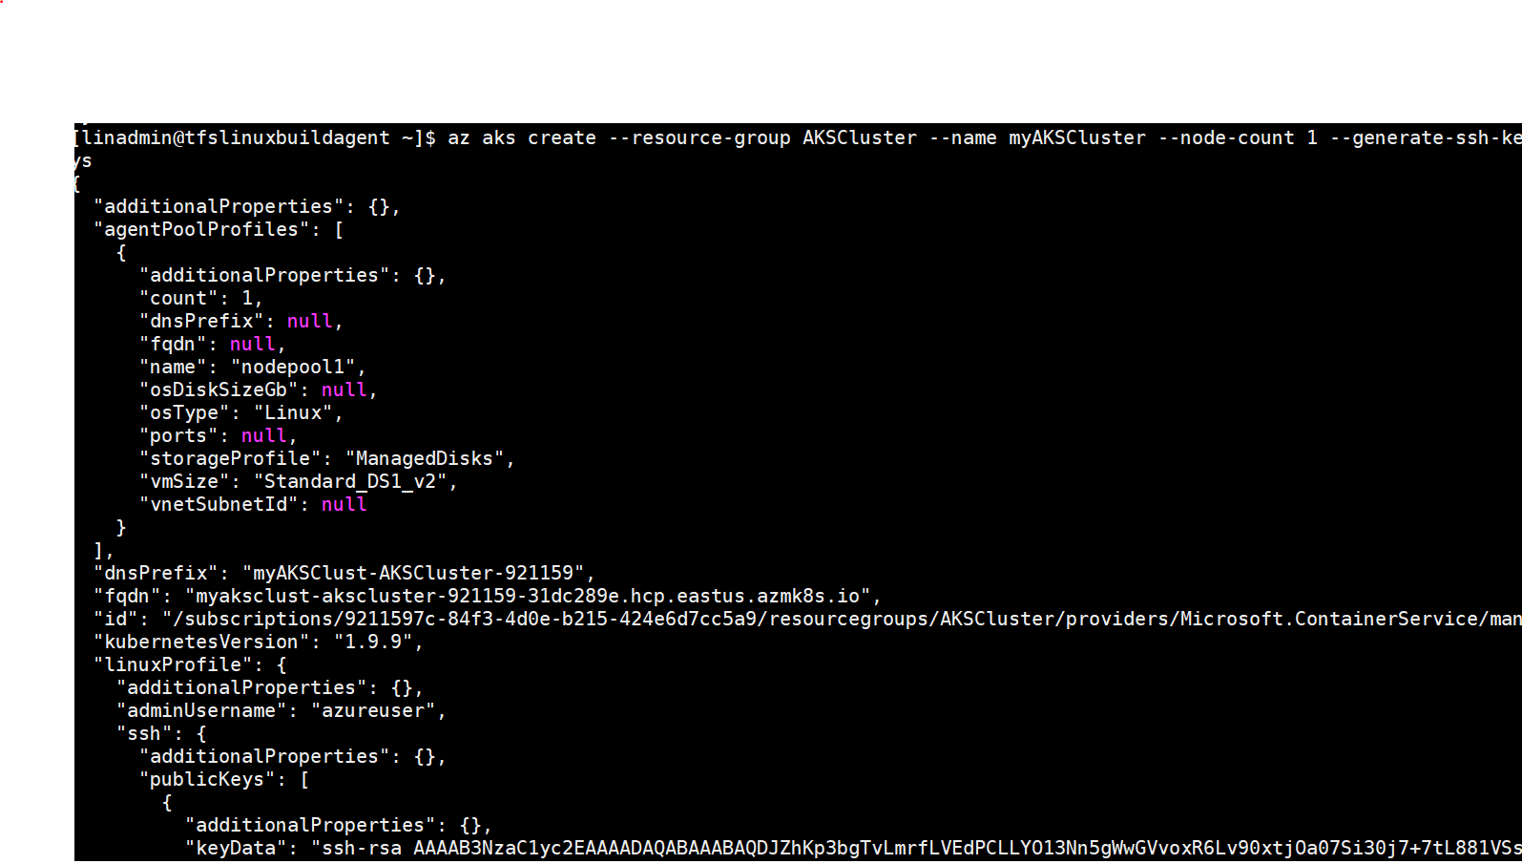

**Connect to the cluster**

To manage a Kubernetes cluster, use kubectl, the Kubernetes command-line client.

To configure kubectl and to connect to Kubernetes cluster, use the az aks get-credentials command, downloads credentials and configures the Kubernetes CLI to use them. And run kubectl get nodes command to return a list of the cluster nodes

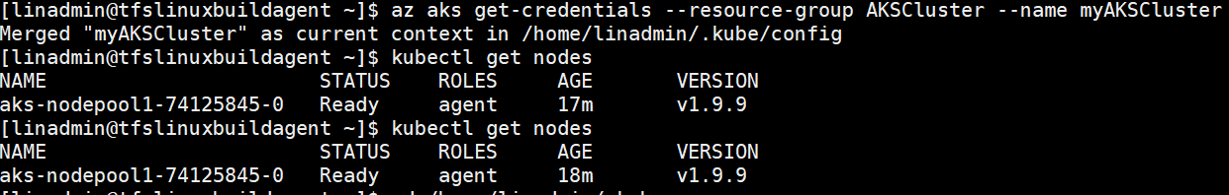

**Run the application**

**Create a file named azure-vote.yaml and copy into it the following YAML code**

# cat azure-vote.yaml

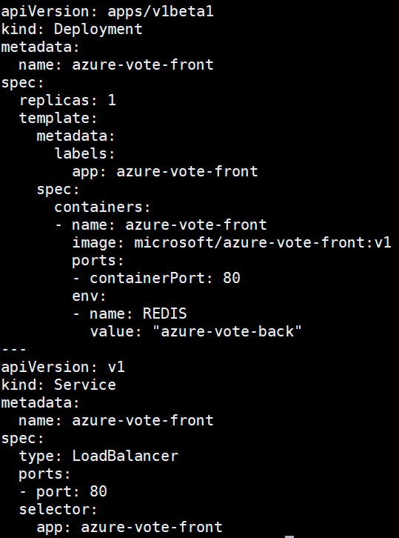

**Use the kubectl apply command to run the application.**

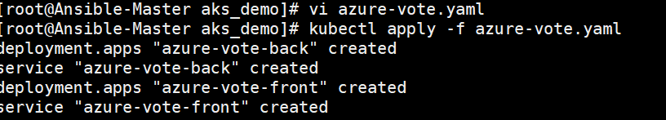

**Test the application**

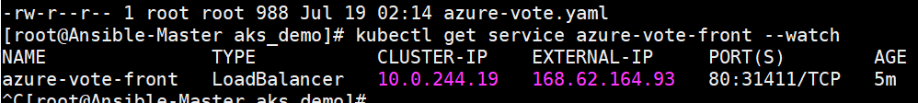

**Now, browse to the external IP address to see the application deployed on k8s cluster.**

